

**PRESS RELEASE** Prague, 18th November 2015

# Last flat sold in Baarova Residential Park

**The Baarova Residential Park has announced the sale of its last available flat. The residential project is part of the multifunctional BB Centrum complex in Prague’s Michle district. The leading Czech development and investment company PASSERINVEST GROUP, a.s. is behind the complex.**

The Baarova Residential Park is located between Baarova, U Michelské školy and Telčská streets. It is bordered on the south by the picturesque Baarův Park with a large fountain, a pétanque field and other attractions for children and adults. From an urbanistic perspective this project represents a fluid transition between the original townhouse buildings and the modern multifunctional BB Centrum complex. It comprises three blocks of flats with 139 flats featuring layouts of from one to six rooms with kitchenettes, from which 49 flats with layouts of from two to four rooms with kitchenettes are for rent. The project, with a reception and 24-hour security, includes an internal garden in an atrium and a playground. Another advantage is the close proximity to the newly-built Brumlovka Park, with a large playground and meadow dedicated to the walking of dogs. Its first phase was completed this year and the park will continue to expand.

The Baarova Residential Park in Prague 4 is strategically located close to the centre, with good traffic accessibility for cars from the D1 motorway and for mass transit from the Budějovická metro station on the C line. BB Centrum also offers a number of shops, services, restaurants and leisure and educational facilities, which all of its residents will surely appreciate.

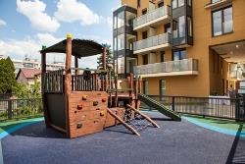

Baarova Residential Park in BB Centrum

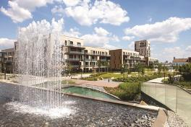

Baarova Residential Park in BB Centrum

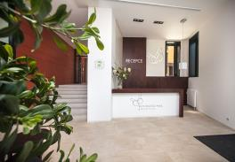

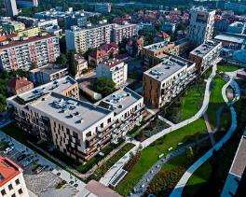Baarova Residential Park in BB Centrum

Baarova Residential Park in BB Centrum

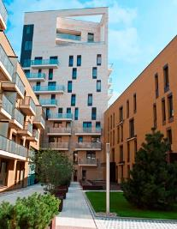

Baarova Residential Park in BB Centrum

For more information and photographs in print quality please contact:

Mgr. Vendula Malochová**,** Marketing Manager

**PASSERINVEST GROUP, a.s.**

Tel.: (+420) 221 582 111, fax: (+420) 222 515 521

Mobil: (+420) 605 318 974

E-mail: [Vendula.Malochova@Passerinvest.cz](mailto:Vendula.Malochova@Passerinvest.cz)

www.passerinvest.cz, [www.bbcentrum.cz](http://www.bbcentrum.cz)

Ing. Marcela Štefcová

**Crest Communications a.s.**

Tel.: (+420) 222 927 125

Mobil: (+420) 731 613 669

E-mail: marcela.stefcova@crestcom.cz

**About the Developer**

**PASSERINVEST GROUP, a.s.,** founded in 1991 by Radim Passer, is a purely Czech development and investment company whose name is associated in particular with the **BB Centrum** multifunctional complex in Prague 4 - Michle. With this project, the most successful and extensive Czech project of its type, the company has built its excellent reputation both at home and at the international level. Contributing to this is not only the high quality of the projects completed to date, but also its high level of service, its sense of fair play, its positive relationship with the tenants and users of its buildings, and its sense of responsibility towards society and the environment. **PASSERINVEST GROUP**’sportfolioincludes other interesting development projects.